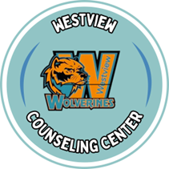
April 2025
* Information below is shared on the counseling Instagram page, our Westview Counseling Webpage and on the Counseling wall
April 1st:
Late Start Students…………………………………………………………………………………….School start time is 9:40
College of St. Mary Lunch Visit…………………………………………………………….....………11:20-1:35 (Commons)
College Possible…………………………………………………………….…………..….......…....…9:00-4:00 (upstairs in the library)
Credit Recovery………………………………………………………………………………………..3:05 – 5:00 (room 123)
Senior Final Countdown ……………………………………………………………………………….3:30 – 5:00 (Counseling center)
April 2nd:
College Possible…………………………………..….......………………………………………....…9:00-4:00 (upstairs in the library)
Educationquest – Andrea………………………………………...……………………………….……8:30-2:30 (109 Conference Room)
Army National Guard Lunch Visit……………….……………………………………………………11:20-1:35 (Commons)
Senior Final Countdown ……………………………………………………………………………….3:30 – 7:00 (Counseling center)
April 3rd:
Credit Recovery………………………………………………………………………………………..3:05 – 5:00 (room 123)
College Possible…………………………………………..……………………………..................….9:00-4:00 (upstairs in the library)
Senior Final Countdown ……………………………………………………………………………….3:30 – 5:00 (Counseling center)
April 4th:
National Honor Society Acceptance letters go out
April 8th: ACT DAY
April 9th:
Avenue Scholar Induction Ceremony……………………………………………………………………10:30 – 1:00pm (offsite)
Marine Corps Luch visit………………………………………………………..………….……………..11:20-1:35 (commons)
April 15th:
College Possible……………………………………………………….……......................................….9:00-4:00 (library)
UNL Luch visit………………………………………………………..………….………….…………...11:20-1:35 (commons)
Credit Recovery…………………………………………………………………………………………..3:05 – 5:00 (room 123)
April 16th:
Educationquest – Andrea………………………………………...……………………………….………8:30-2:30 (109 Conference Room)
College Possible…………………………………………..……………………………......................….9:00-4:00 (upstairs in the library)
Navy Luch visit………………………………………………………..………….………….…………...11:20-1:35 (commons)
April 17th:
Iowa Western Community College visit (at Campus)
College Possible…………………………………………..……………………………......................….9:00-4:00 (upstairs in the library)
Senior Meeting……………………………………………………………………………………………9:15 – 9:45 (Theater)
Credit Recovery…………………………………………………………………………………………..3:05 – 5:00 (room 123)
April 18th: No School - Students
DEADLINE FOR CAP & GOWN ORDERS
(Purchase Cap & Gown online Westview High School Bennington, NE - Cap, Gown & Tassel Unit w/ Stole - Jostens or in the store:
12100 West Center Road, Suite 202. Open on Tuesday and Thursday 10-5:30 pm.)

April 21st: No School - Students

April 22nd:
College Possible…………………………………………..……………………………......................….9:00-4:00 (upstairs in the library)
Credit Recovery……………………………………………………………………..……………………3:05 – 5:00 (room 123)
April 23rd:
College Possible…………………………………………..……………………………......................….9:00-4:00 (upstairs in the library)
Southeast College Visit (at Campus)
Army Luch visit………………………..……………………………..………….………….……….…...11:20-1:35 (commons)
April 24th:
College Possible…………………………………………..……………………………......................….9:00-4:00 (upstairs in the library)
UNL High Ability Visit……………………………………………………………..………….…………9:15 – 9:45 (counseling)
Credit Recovery……………………………………………………………………..……………………3:05 – 5:00 (room 123)
National Honor Society Induction
April 28th:
College Possible…………………………………………..……………………………......................….9:00-4:00 (upstairs in the library)
April 29th:
College Possible…………………………………………..……………………………......................….9:00-4:00 (upstairs in the library)
Nebraska Wesleyan University Visit (at Campus)
Credit Recovery……………………………………………………………………..……………………3:05 – 5:00 (room 123)
April 30th:
LAST DAY TO CHANGE COURSES FOR NEXT SCHOOL YEAR
College Possible…………………………………………..……………………………......................….9:00-4:00 (upstairs in the library)
Q4 Senior Meeting………………………………………………………………………………………..9:15 – 9:45 (Theater)
Marine Corps Luch visit………………………..… ………………..………….………….……….…....11:20-1:35 (commons)
SENIORS! … SENIORS!! … SENIORS!!!

April 1st, 2nd, and 3rd – Senior Countdown (see flier below)
April 25th - Scholarship and awards due to counseling for recognition at Honors Night
April 12th- Prom 8:00pm – 11:00pm at the Ackerhurst Dairie Barn (15220 Military Road)
After prom will take place at Westview High School.
May 5th - 6:00pm – Senior Honors Night – Westview Theater
May 9th – Seniors last Day! Senior Meeting in the morning and picnic to follow
May 22nd - 10:30am graduation practice at Baxter. Must attend
May 23rd - 7:00pm Graduation! Must have a cap, gown, stole and tassel

Purchase Cap & Gown online Westview High School Bennington, NE - Cap, Gown & Tassel Unit w/ Stole - Jostens or in the store: 12100 West Center Road, Suite 202. They are only open on Tuesday and Thursday 10-5:30 pm.

Do you have fines that need to be paid before you graduate? Check with your counselor or Ms. Erin.

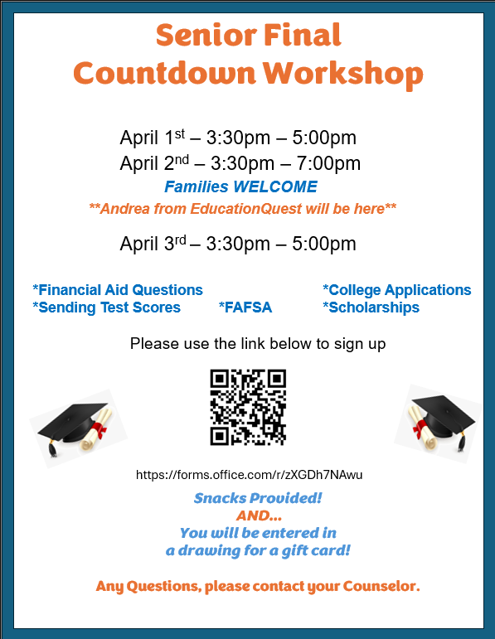
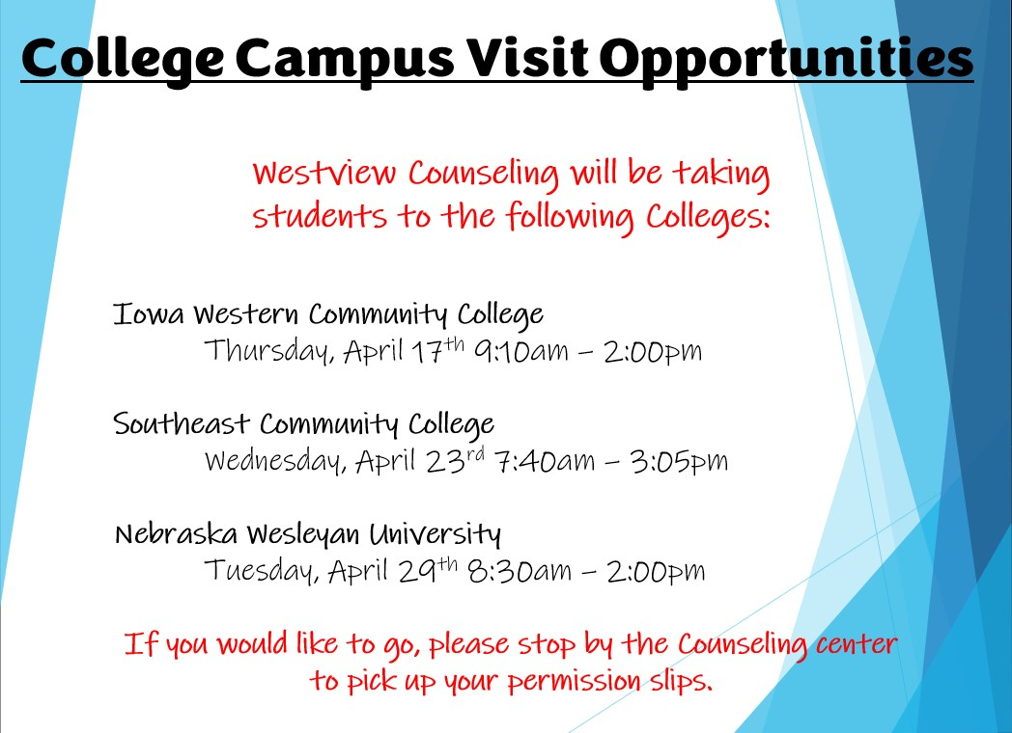


Please make an appointment with the Westview High School Counseling office 48 hours in advance. We want to make sure that we set aside the proper amount of uninterrupted time for you and/or your family.
Thank you from the Westview Counseling Staff.

https://forms.office.com/Pages/ResponsePage.aspx?id=tm3mWBshN0q36A72lnQgwd7Jht2nacJHr02SwAA3RQJUMUdETTg5Vk9OOENCMFQ2UDNGQ1ZaUTU0Ty4u

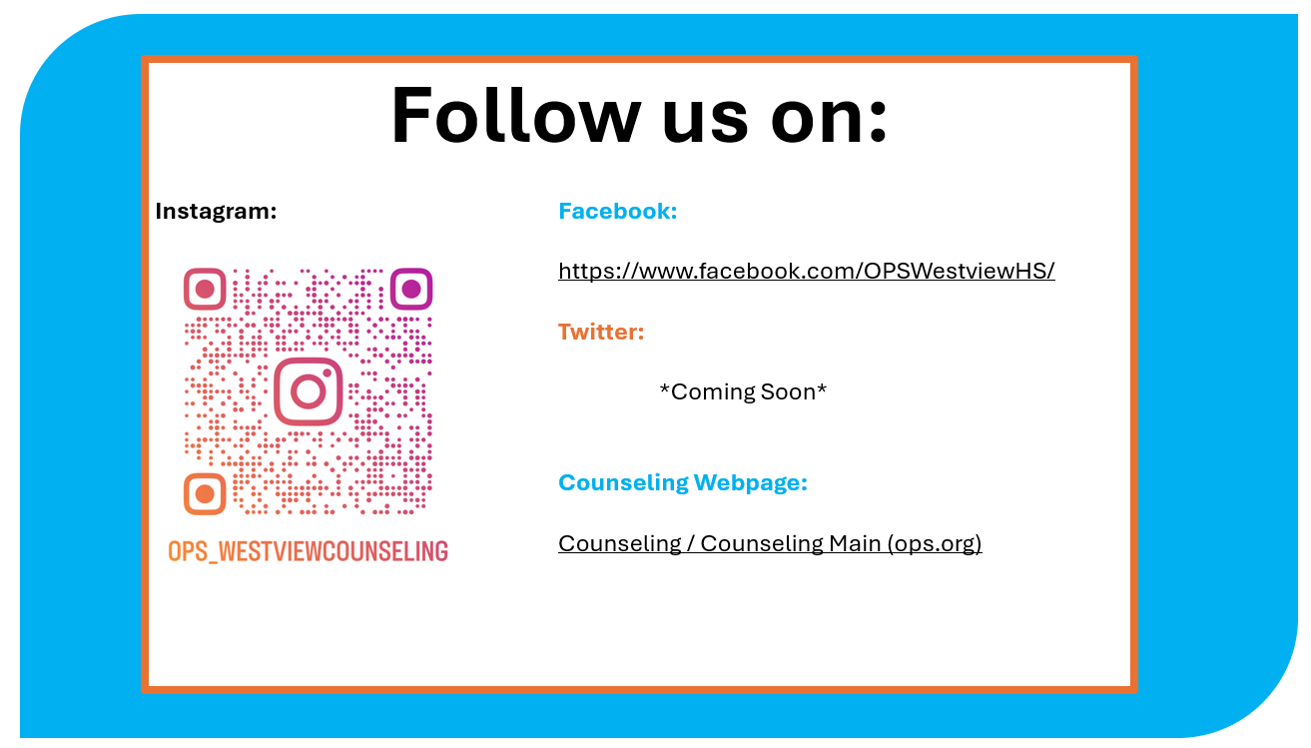

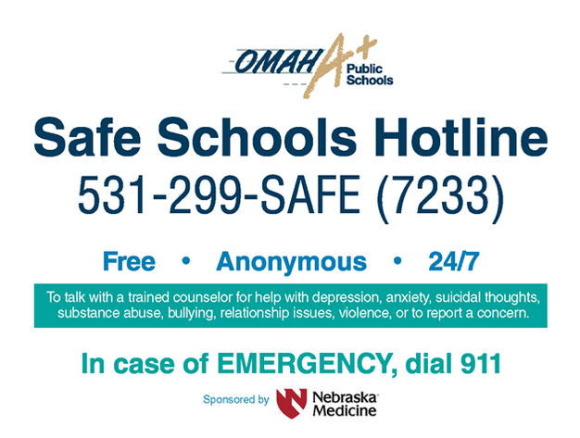

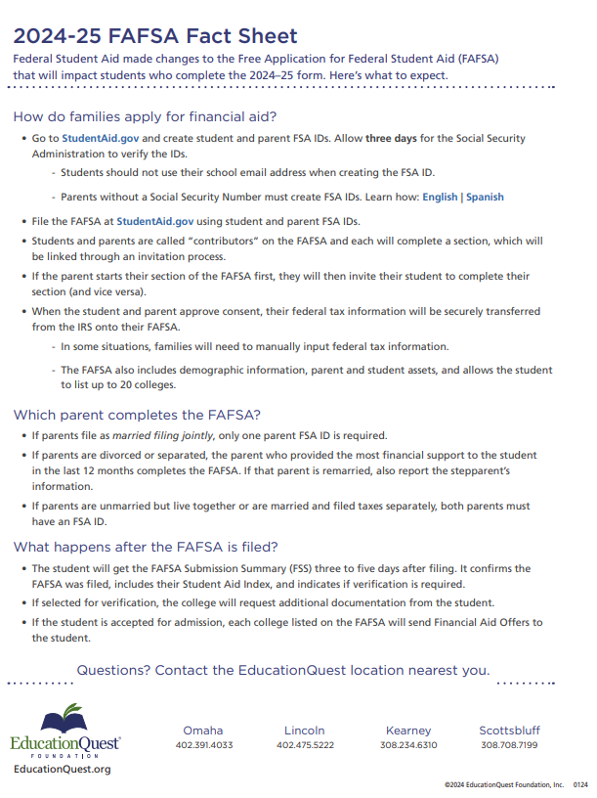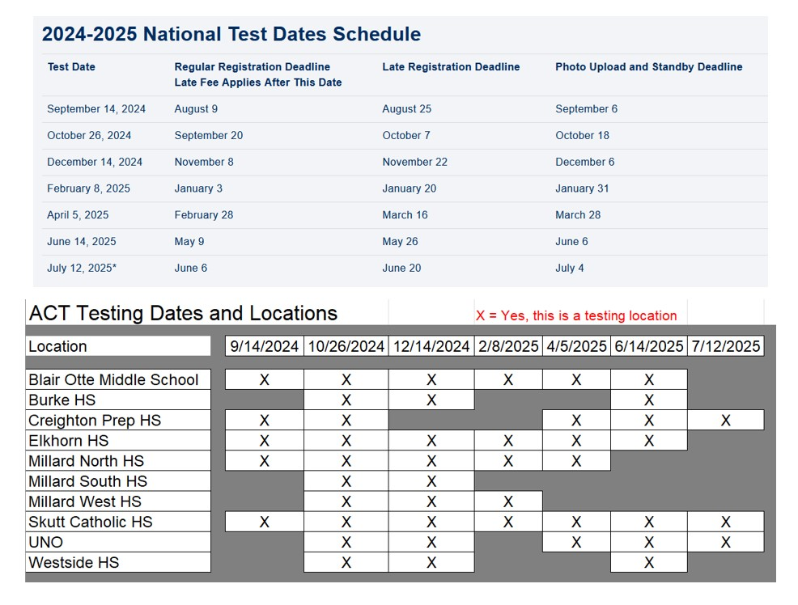

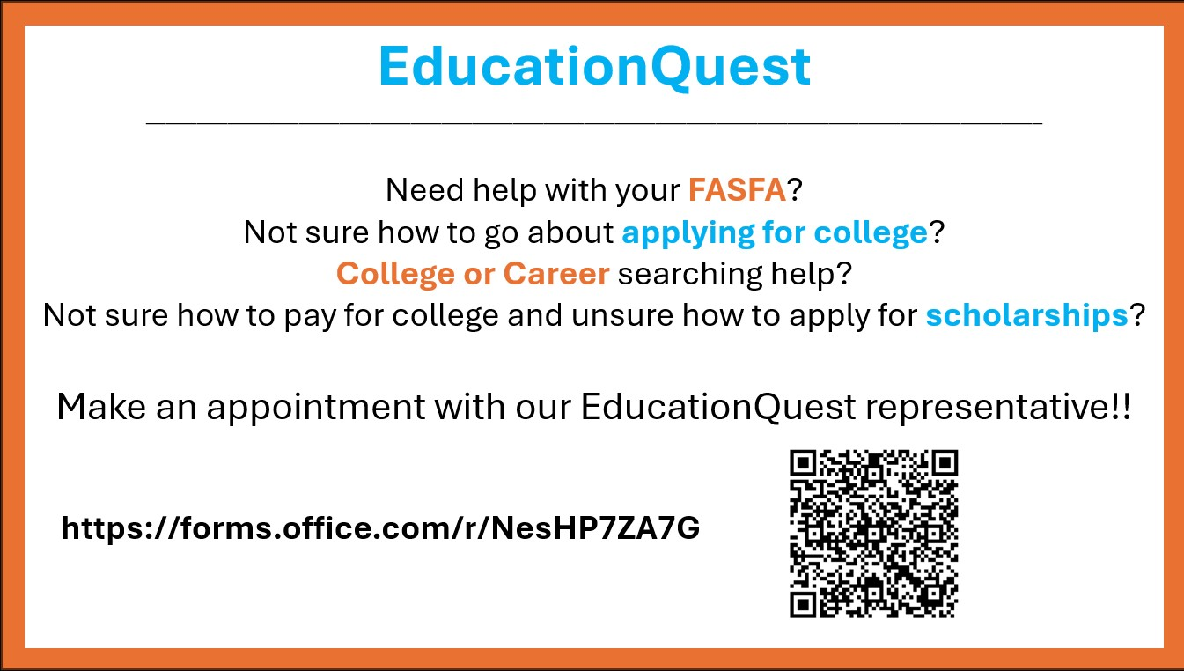



Needing help with an assignment? Have a paper that you would like reviewed? Can’t make it to after-school tutoring because you have practice, a game, club, or even work? Have no fear! You can use the Paper tutoring app on your iPad. Paper can be found within Clever on your iPad. What is Paper? It is a free tutoring program for all OPS students that you can access until 11:00 pm each night 7 days a week. Omaha Public Schools introduced a new option for Academic Support and Tutoring this month.
Our district partnered with Paper for online tutoring services for students and families. Through online tutoring with Paper, students in grades 3-12 have access to the following:﻿
    - 1:1 live chat tutoring session with experts
    - Support in 200 subjects
    - Available in English, Spanish, French and Mandarin
    - Expert review of written work (essays, creative writing, poetry, lab reports)
    - Hundreds of resources and activities for families support students at home.

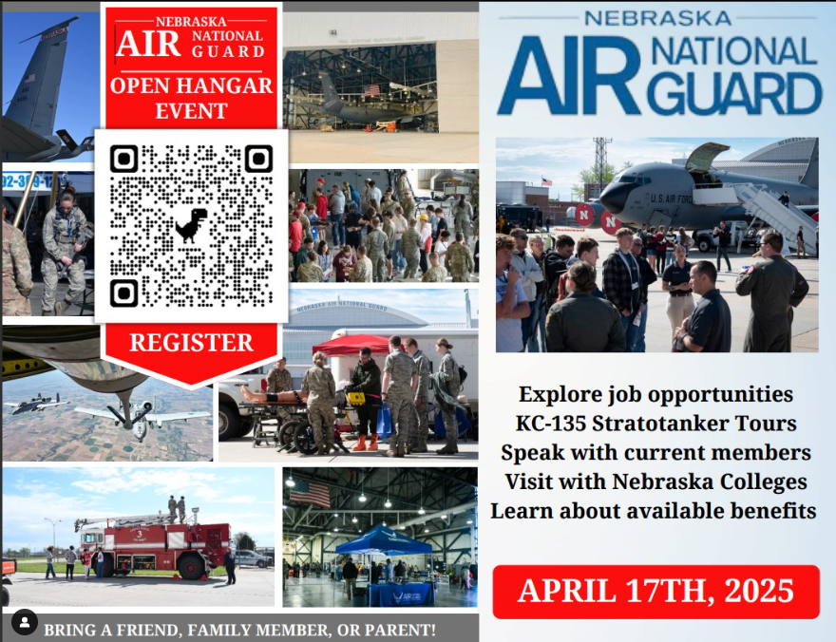
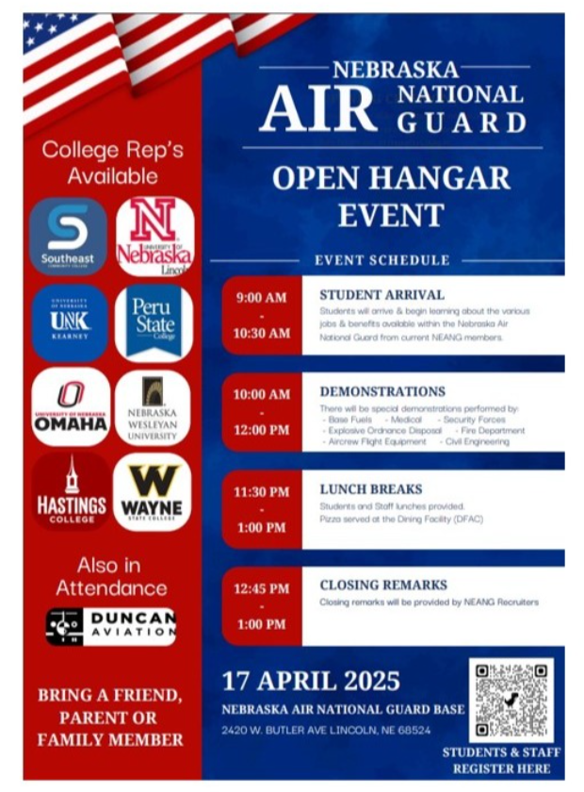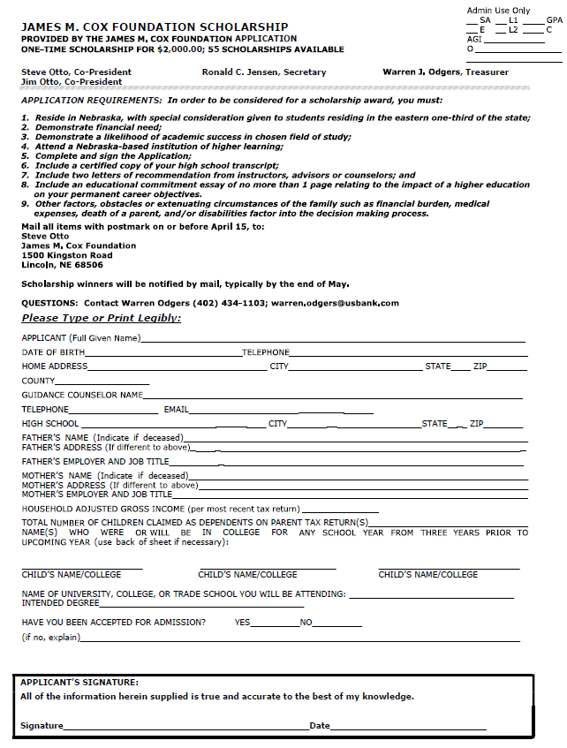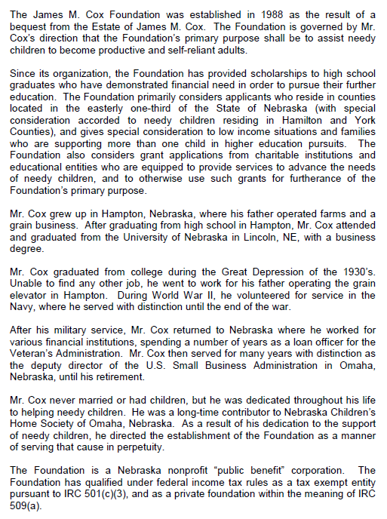

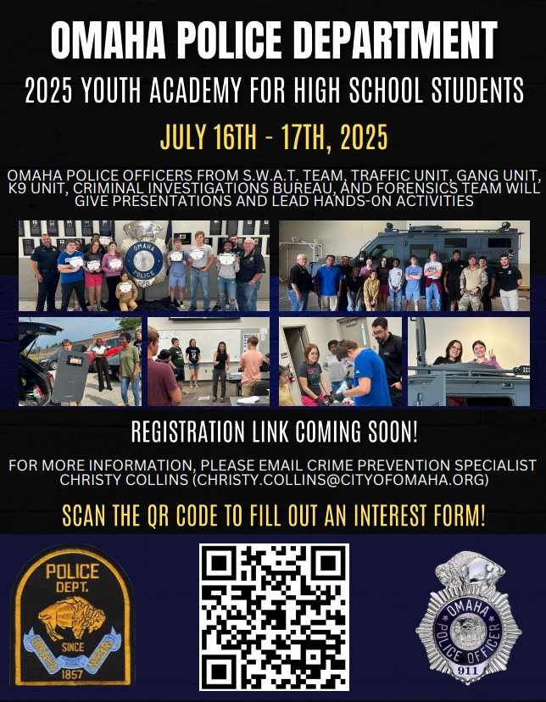
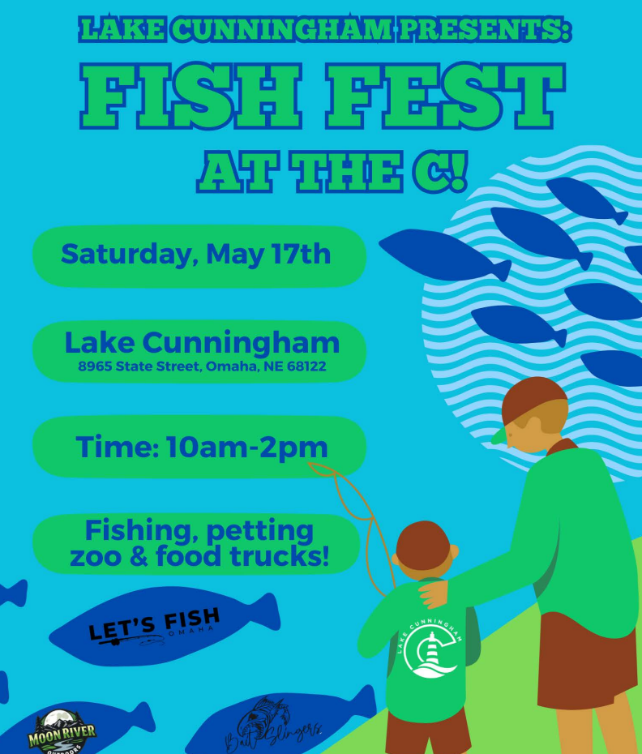

Come Explore the World of
Pediatric Nursing!

Saturday, April 5th, 2025
8:00am - 12:00pm
8200 Dodge Street, Omaha, NE 68114

﻿Join the Children's Nebraska Team for this free, half-day learning experience for high school students interested in a career in nursing. The day will consist of hands-on activities, immersive breakouts, an interactive panel and much more!

Plus, connect with our partner colleges and universities who will be onsite to help walk you through the educational journey of your desired career!

What The Day Will Look Like:
CPR Training and Competition
Ambulatory Procedures
Working with our Nursing Simulation Team
Tour of Different Hospital Departments
Interactive Nurses Panel

Space is limited - Register today!

